***Report on***

Firti Gari

***Prepared for***

# AKM Ahsanul Hoque, Adjunct Professor & Consultant CSE3036.2 & Information System & Software Engineering Lab

***Prepared by* Lab Section: CSE3036.2 Group Name: Team Pie**

# Tanzim Hasan_2018200000038 Sourov Das Tomal_2018200000034

**Mahfuza Khandokar Rifath_2018200000028 MD. Mehedi Hasan_2018200000005**

***Date:19/06/2022***



***Southeast University***

***Department of Computer Science and Engineering\****

### Summary:

Currently we have several ride sharing Apps. But we came up with a new feature. Our main goal here is - let the long distance user/passenger know that the gari will be return on a day at this time as in this pandemic many of us prefer not to use bus instant of gari. So, it is a kind of hassle for them to book a gari on his/her own. And it's pretty much costly. Using this app/software it will redact the hassle and also have friendly buzzes and make a convenient journey.

Let someone want to go a long distance where ride sharing (pathao /uber) services are not available. We know ride sharing services are currently available in Dhaka city or any crowded city in the country. In this pandemic, if someone wants to go to a place where transportation is not good enough, In this situation, if someone wants to go without hassle & a cheap cost **FIRTI GARI** can help them.

Here **FIRTI GARI** concepts are quite unique, here a traveler can know the return time & date. Normally a driver drops a passenger to their required place and returns without a passenger. Maximum time, passengers have to pay double price as the Drive**r** has to return without passengers.

So, before going somewhere, the driver might enter data about the time and date, when he/she returns. As a result, other passengers (those who want to travel next) may be informed of the return date, and he or she may hire the driver for their next journey if the passenger desires. To do this the customers will save their money & time.

### Introduction:

Project **FIRTI GARI**, the main theme of this project is to save time, energy and money and make the journey comfortable. In this project, we want to build an App which will provide information about transportation. We make an investigation when the people face problems with their journey. In our country the most common transportations are railways, roadways and waterways. In this software the user can get information about the availability of transport. For example, when someone wants to go on a long tour they need to hire a vehicle, which is very costly. By using this software the users can know the availability of transportations.

The FIRTI GARI idea is completely remarkable because it allows a passenger to see the return time and date. Normally, a van drops a passenger off with their destination and then returns without anybody. Passengers must pay approximately twice the charge if the driver is required to return without passengers for an extended period of time.

### Background of the Study:

The main concept of this project is we want to make peoples journey comfortable. In this software the user can get information about the availability of transport in the neighboring areas. We are trying to make sure that our every transport will be available where people are facing trouble finding vehicles. And users also can hire the vehicles with a reasonable cost.

### Objectives:

**Primary objective:**

* The user can find out about transportation options in the surrounding locations, and every way of travel will be available in areas where people are having difficulty finding vehicles.

### Secondary objective:

* Reduce time and make the journey more pleasant.
* User can give information when he/she will available on that specific place.

**Methodology:**

### Process Model:

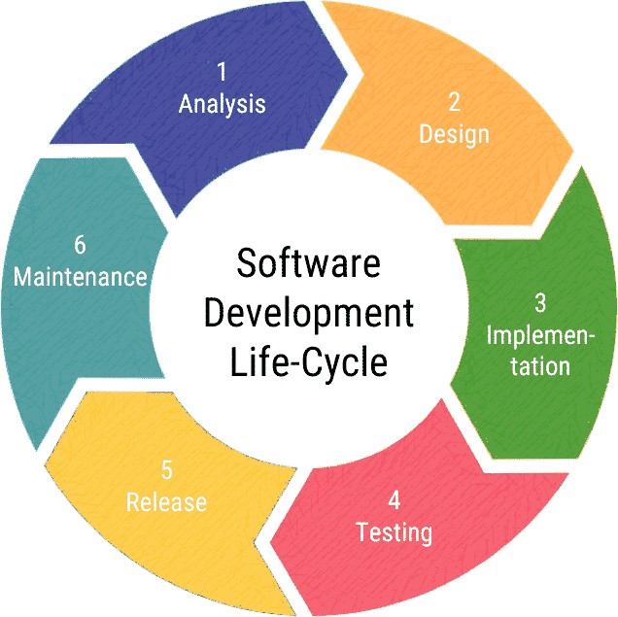

In this project we are choosing the agile method because we want to update or customize this system by the user feedback or response. We know in agile

methods the customer and the development team should collaborate, promoting team and product synchronization. Agile approaches encourage long-term which boosts productivity.

**The Project**

### Communication:

As we are in a pandemic, our team will not be able to visit any physical location. So, made a survey & made decision based on it. In our survey we get some positive feedback which is almost similar to our concept. So we hope after building this project we will get a positive response.

1. **Planning:**
2. **PERT:**

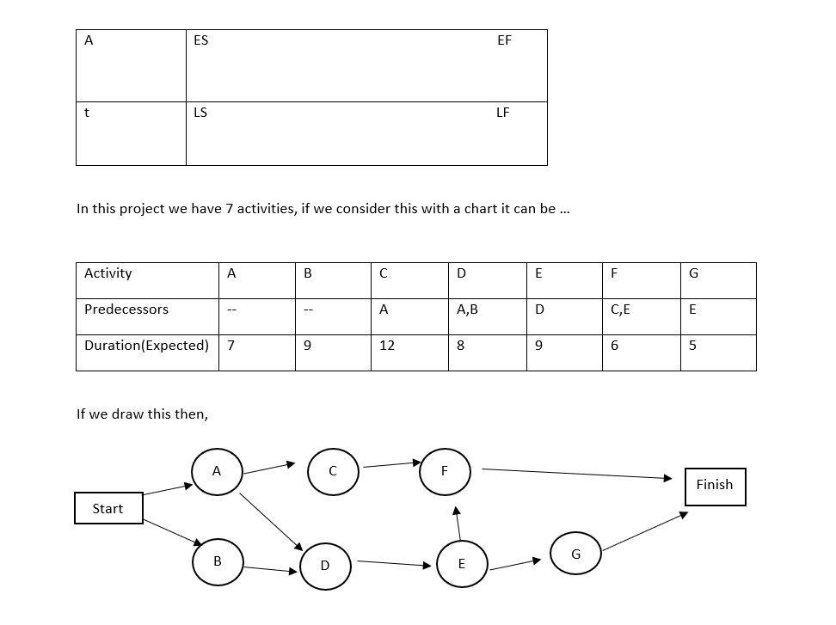

1. **CPM:**

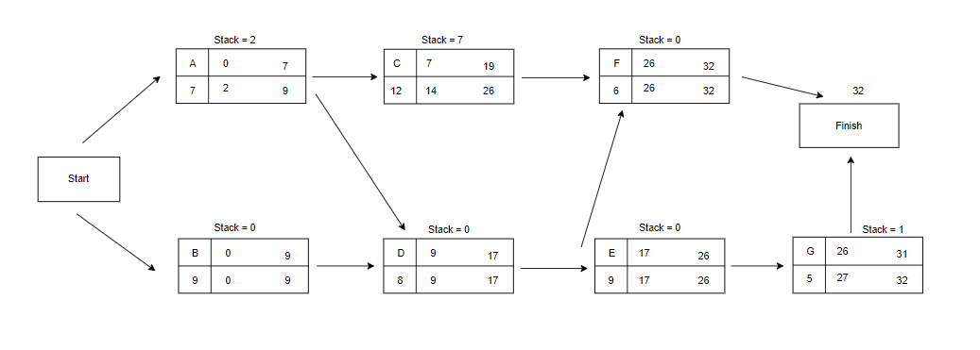

Now we can calculate stack

Stack = LS – ES or LG – EG

Stack = 0

1. **Gantt Chart / Time Chart:**
2. **Project Estimation:**

**Estimation information domain value**

|  |  |  |  |  |  |  |
| --- | --- | --- | --- | --- | --- | --- |
| **Information domain value** | **Opt.** | **Likely** | **Pess.** | **Es. count** | **Weight** | **FP count** |
| **1.Name of external input** | 2 | 2 | 3 | 3 | 4 | 9 |
| **2.Name of external output** | 1 | 2 | 3 | 2 | 5 | 10 |
| **3.Name of external inquiries** | 2 | 1 | 2 | 1 | 5 | 7 |
| **4.Name of internal logical file** | 6 | 3 | 7 | 4 | 10 | 42 |
| **5.Name of external interface files** | 2 | 2 | 3 | 2 | 7 | 15 |
| **Unadjusted FP count** |  |  |  |  |  | 83 |

FP = UFP × CAF

UFP = Unadjusted Function Point

CAF = Complexity Adjusted Function point

**Complexity Adjustment Factor is calculated using 14 aspects of processing complexity and these 14 questions answered on a scale of 0-5**

**0 - No Influences or No Important**

**1 - Incidental**

**2 - Moderate**

**3 - Average**

**4 - Significant**

1. Data Communication

2. Distributed Data Processing

3. Performance

4. Heavily Used Configuration

5. Transaction Role

6. Online Data Entry

7. End-User Efficiency

8. Online Update

9. Complex Processing

10. Reusability

11. Installation Ease

12. Operational Ease

13. Multiple Sites

14. Facilitate Change

**Factor Value**

Backup and recovery 4

Date communication 1

Distributed processing 5

Performance critical 4

Existing operating 3

Online data entry 5

Input transaction-

over multiple screen 5

Master files-

update online 4

Infor domain-

value complex 3

Internal processing 5

Code design for reuse 4

Convention/Installation 0

Multiple Installation 3

Application design 5

51

Value adjustment factor = 0.65+0.01×£f1

FP estimation = w = 97

Let,

Average production Y = 6.5 FP\pm

Labor rate = Y = $6,500 per month

So,

Cost per FP = Z = Y/X = 6500/6.5

= $1000(approx)

Total estimate project cost = w*z

= 97*1000

= $97000(approx)

**Project budget:**

## As it is a high configuration system. We are trying to make this system much standard and unique at a reasonable cost. To make this project we analyze that we need 10,000,00tk for marketing cost, developer cost, maintenance cost, employee cost, ads etc.

### Cost-Benefit Analysis:

**Two ways to describe cost-benefit analysis:**

* Tangible.
* Intangible.

### Tangible-Cost:

We need just technician cost because it is a software based project. But, if we need any kind of tool, it will be less expensive. Cost of resources also added.

### Intangible-Cost:

If the system is not working as we expected, then the reputation of the organization is diminishing day by day.

### Tangible-Benefits:

People may use our system widely and it will help us economically. If we increase the speed of processing, we will get more benefits. Also, if we finish our task before schedule it will decrease the cost of salary. If the project goes successfully, the organization can earn a lot of cash.

### Intangible-Benefits:

The reputation of the organization will increase. We can also save our resources if the project is finish before the deadline.

1. **Risk Analysis:**

Risk analysis is the process of identifying and analyzing potential issues that could negatively impact key business initiatives or projects.

3 steps of risk analysis

* Risk identification.
* Risk analysis.
* Risk evaluation.

|  |  |
| --- | --- |
| **Risk** | **Description** |
| Generic Risk | Generic threats across all projects. For example, requirements change, loss of team members, loss of funding. |
| Product-  Specific risk | High level risks associated with the type of product being developed. For example, availability of testing resources. |
| Project risks | Affect project schedule or resources |
| Product risks | Affect quality or performance of software |
| Business risks | Affect the viability of the software. |

**Feasibility Study:**

**operational:**

We have enough human resources to operate the system. Users can easily communicate with our operatives through the system. Our operative team will maintain the system regularly. So, if we need to expand on upgrading our system we can easily do it with our resources.

**Economical:**

It is a software based project so we don’t need any expensive tools. Most of the tools are free. So, the organization doesn't need to make a big amount of budget.

**Technical Feasibility:**

We have enough resources and technology to run and build the system. We have also manpower to operate the system. In future, if the system requires new feature, we can upgrade it easily. Also, we can upgrade or add our technology if we require.

1. **Modeling:**
2. **Project features:**

**Register:** The Driver give his full information (name, id, add etc) as we have to know who is driving.

**Location:** As our main roll is drive, so driver need to enter his/her location where he ends his ride and enroll his destination area.

**Day:** Notify drivers returning day.

**Time:** Driver need to set his arriving time and also return time.

**Login:** Now passenger first need to open the app as passenger also need to know when the driver will finish his ride and which day he come and also the time.

**Pay bill:** Reasonable cost.

1. **Use case diagram**

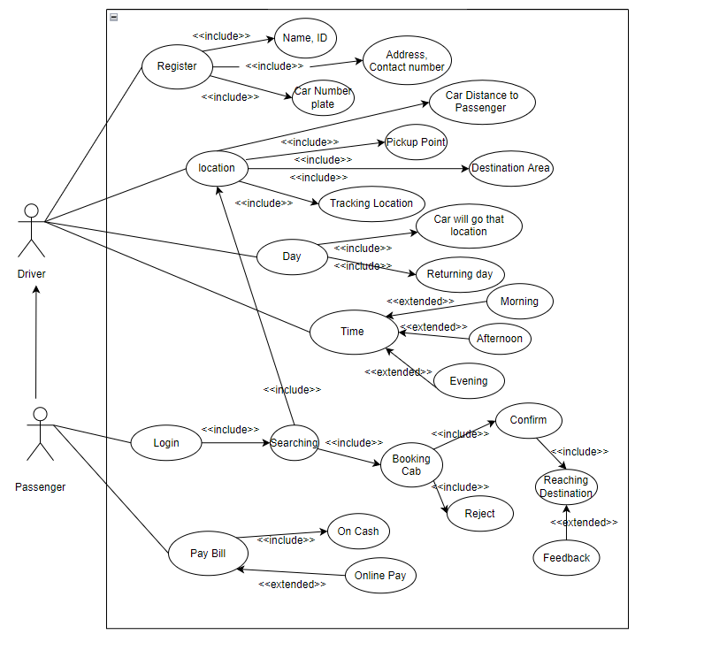

1. **Use case Narratives:**

|  |  |
| --- | --- |
| **ID:** | FirtiGari |
| **Title:** | Project Firti Gari |
| **Description:** | The main goal of this project is we want to make peoples journey comfortable. In this software the user can get information about the availability of transport in the neighboring areas. We are trying to make sure that our every transport will be available where people are facing trouble finding vehicles. And users also can hire the vehicles with a reasonable cost. |
| **Primary Actor:** | Our primary actor is the Driver. |
| **Secondary Actor:** | Our secondary actor is the passenger. |
| **Preconditions:** | The users must be logged in. |
| **Postconditions:** | The system had to save all the information after completing the ride. |
| **Main Success Scenario:** |  |
| **Frequently of Use:** | We hope that after completing our project the users can frequently use the software and they can enjoy the save ride. |
| **Status:** |  |
| **Owner/Author:** |  |
| **Priority:** | The priority of this use case is very high. |

1. **Class Diagram:**

**CRC**

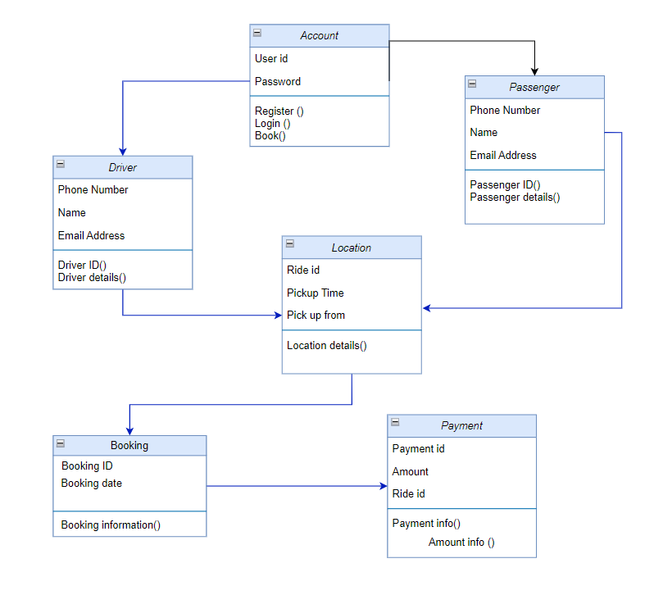

1. **Activity Diagram:**

**Drivers Activity:**

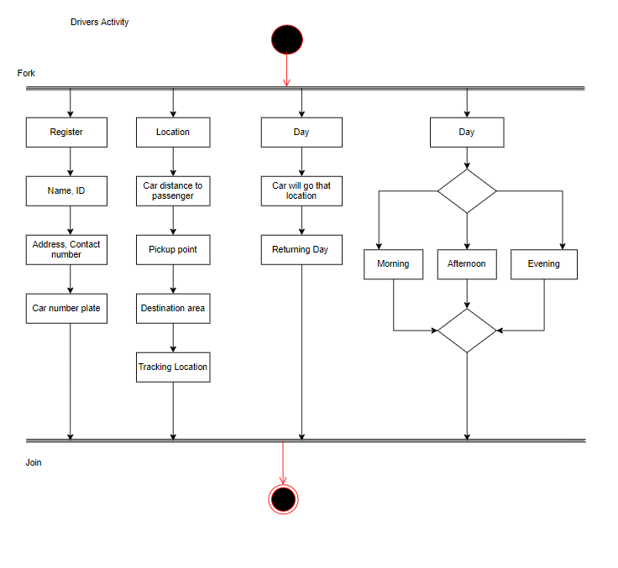

**Passengers Activity:**

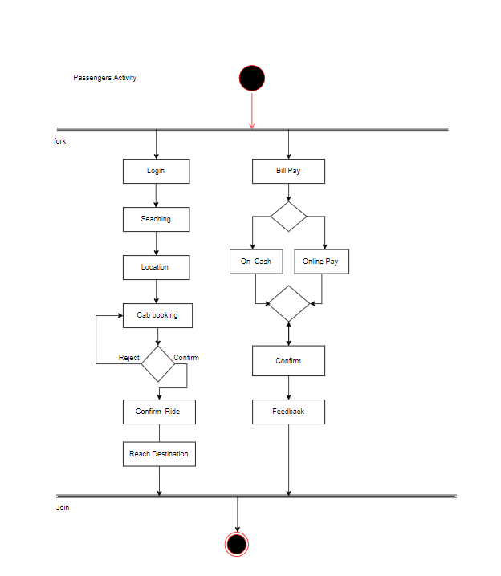

1. **Swimlane Diagram:**

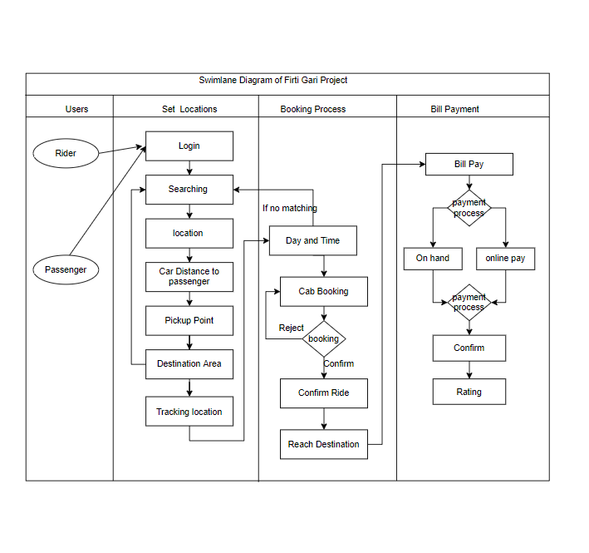

1. **Data flow diagram:**

**Context Diagram**

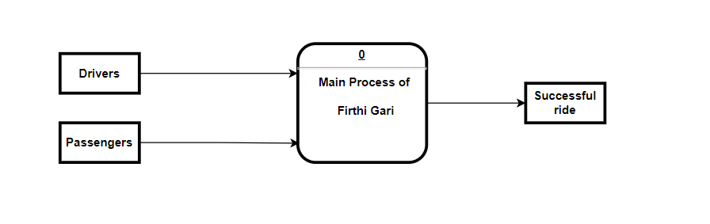

**O level Diagram:**

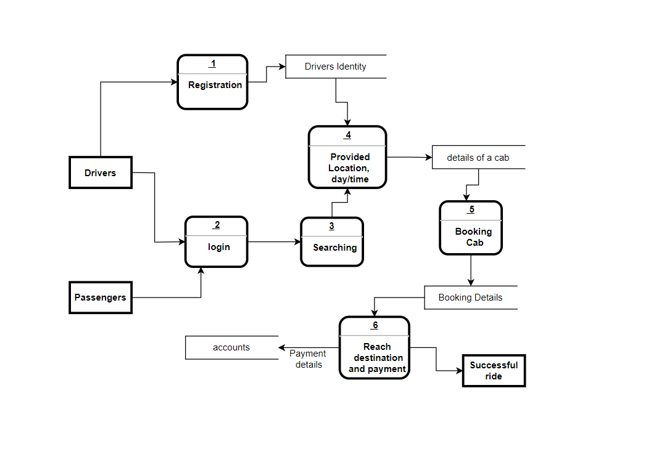

**SWOT Analysis of your project**

|  |  |  |  |
| --- | --- | --- | --- |
| Strengths | Weakness | Opportunities | Threats |
| **Capital stock:** We have established and maintained a strong capital base**.**  **Marketing:** Aggressive and focused marketing campaign with clear goals and strategy.  Management team: Good team of people. | **Quick Expansion:** There are a lot of new hires to train and organize structures to learn.  **New:** Not well known in market.  **Employee:** Increasing employee cost.  **Office:** No office presence. | **Issue:** We have quick access in customer issue.  **Investment:** Increase investment quality.  Target and improve our system.  **Community:** we have strong, loyal & community.  **Profit:** Ability to find more profit. | **Brand:** Brand impersonality and mediocre engagement  **Competition:** Global competition is challenging.  **Customer demand:** it’s quite challenging to ensure quality product as technology & customer demand change rapidly.  Increate operation cost |

**m. Schema Diagram:**

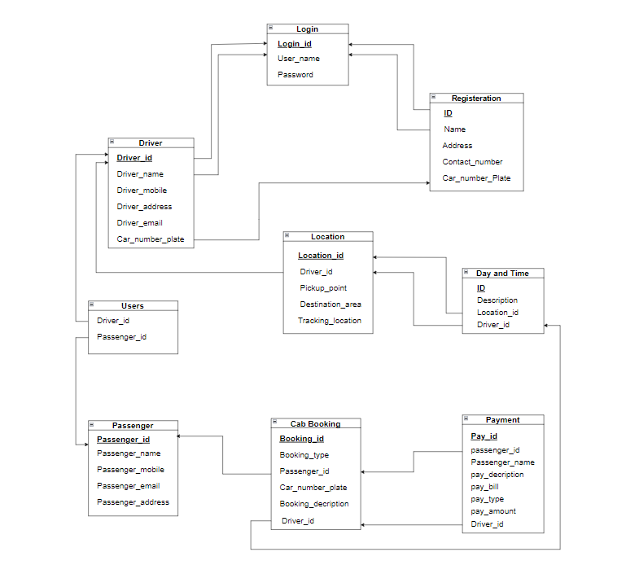

**p. ERD**

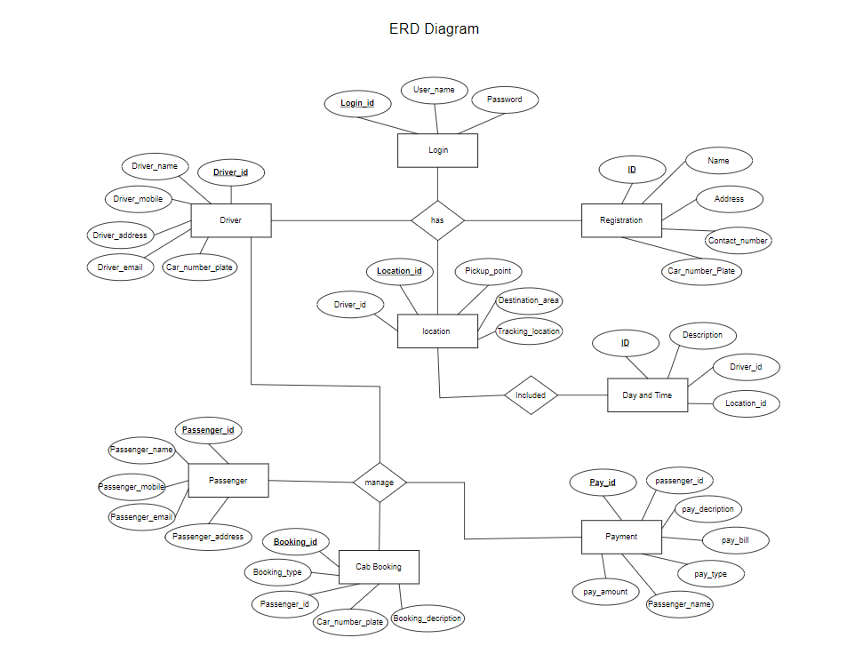

**4.Construction:**

In simple, the development environment is a workspace with a set of processes and programming tools used to develop the source code for an application or software product.

**Language:**

In this project we use JAVA (For app)

For our website we use (Frontend) HTML, CSS, BOOTSTRAP, Js (React)

For backend we use node Js, we use MYSQL for Database.

**Testing Strategy:**

At 1st we use unit testing during the coding phase by the developers. After that for combining the units we used Integration testing then we test for Acceptance and performance. In the last stage we test our Security and Usability. After that we release our App

**Testing techniques:**

We go through with this technique in our project

* Unit testing.
* Integration testing.
* Acceptance testing
* Performance testing
* Security testing
* Usability testing

**A. Deployment:**

The deployment process flow consists of 5 steps:

* Planning
* development
* testing
* deploying
* monitoring

We build our software in Agile approach .so, this all are used in a single step then another step like this.

**B. AMC (Annual Maintenance Contract):**

An AMC can last from 1 to 5 years (as agreed to by the parties). Typically, AMCs include service support, that will cover IT support and replacement as well. As it’s our own product so we will maintain it as our own.

**C. Support and Maintenance:**

Here, the software vendor provide technical support for an existing software product for their customers. Sometimes it may also extend the expiration date of certain features, like as new releases or upgrades or something like that. After releasing our product we will assign for this purpose.

**6.Learning Experiences:**

**Tanzim Hasan:**

Over the semester, I have learned more than expectation. Taking this class has assured me that I have the power to make a difference and become and entrepreneur. I learned valuable life lesson for enduring Software Engineering field. By doing this project, I gained more experience in Entrepreneurial Problem solving.Though it’s quite challenging for me but your support make it easy. Now, I found myself falling in love with our project & it’s become our dream project.

At the end I thanked you for taking this Course.

**Sourov Das Tomal:**

By doing this project, I have learned many things. In the whole semester from this course I known that to build a system or a software, we have to make a pre-plan. The main important thing is that I known only coding is not enough to build a system. We have to survey and analysis for this. To complete this project I faced many difficulties and I have learn how to solve the problems. Though it’s quite difficult and challenging for us but your support make us easy to build this project. By completing the project it encourage me to made many creative things. At the end I thanked you Sir for taking this course with us.

**Mahfuza Khandokar Rifath:**

This hole semester i experienced a lot and it’s my first project doing my entire varsity life. So now i know what the project looks like. While doing project firti gari I had difficulty but learned new things .I worked in a team but now I realize that working in a team is not an easy task. All in all it was a good feeling working as a team. I learned about new tools and now I am able to design a software by using it. So, all in all I was able to learn something new. Finally I want to thank you sir for taking this course.

**MD. Mehedi Hasan:**

**7. Conclusion:**

Several ride sharing app in running on the market but we come up with a new feature, though it’s challenging for us to grab the market but We think this idea will save time and money for the passenger. We learned several things while doing this project. Teamwork, professional attitude and many more. Without your support it’s impossible for us.